How to Request Swipe Access to the ECE Integrated Design Studio – AMP

Purpose
This process is for AMP members requesting swipe access to the ECE Integrated Design Studio in Whittemore 234.
Swipe access allows approved AMP members to enter the lab. Access to the lab does not override AMP membership, project, safety, or resource-use requirements.
Requirements
Before requesting swipe access, you must:
- Be an approved AMP member
- Have an approved AMP project proposal
- Complete all required Virginia Tech Environmental Health and Safety (EHS) training
- Read the ECE Design Studio Policy
- Complete and sign the ECE Integrated Design Studio Waiver
1. Complete the Required EHS Training
Complete the following Virginia Tech Environmental Health and Safety (EHS) trainings:
- Electrical Awareness
- HAZCOM RTK
- Hand and Power Tool Safety
- Personal Protective Equipment (PPE) Awareness
- Portable Fire Extinguishers
EHS trainings can be accessed at:
https://ehss.vt.edu/train.php
Your Required Training page should show all five required trainings as completed.
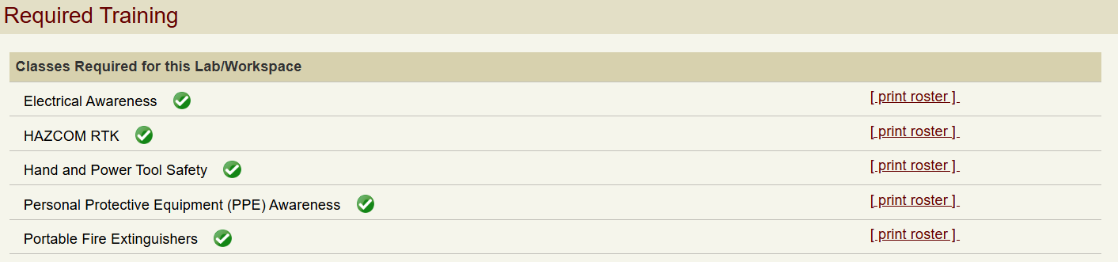
2. Read the ECE Design Studio Policy
Read the current ECE Design Studio Policy provided on the Swipe Access webpage.
The policy outlines the general rules, safety requirements, equipment use, and expectations for working in the ECE Integrated Design Studio.
3. Complete the ECE Integrated Design Studio Waiver
Read, complete, and sign the ECE Integrated Design Studio Waiver provided on the Swipe Access webpage.
4. Submit Your AMP Swipe Access Information
Submit the required information through the AMP Lab New Member Onboarding Form.
You will need to provide:
- Proof of completion of all required EHS trainings
- Completed and signed ECE Integrated Design Studio Waiver
- Your PID
- Your Hokie ID number
- Your approved Project Proposal presentation
- A link to your AMP project GitHub repository
Once all required information has been submitted and verified, your swipe access request for Whittemore 234 can be processed.
Important
Swipe access to Whittemore 234 is only provided to approved AMP members who have completed the required onboarding process.
AMP equipment, components, tools, workspaces, and other resources are reserved for active AMP members working on approved AMP projects.

